A Major Project Synopsis on

**Blockwave**

Submitted to Manipal University, Jaipur

Towards the partial fulfillment for the Award of the Degree of

**MASTER OF COMPUTER APPLICATIONS**

2023-2025

by

Shahid malik

23FS20MCA00064



Under the guidance of

Mrs Swami Nisha Bhagirath

**Department of Computer Applications**

**School of AIML, IoT&IS, CCE, DS and Computer Applications**

**Faculty of Science, Technology and Architecture**

**Manipal University Jaipur**

**Jaipur, Rajasthan**

**2025**

1. **Introduction**

BlockWave is an innovative and user-friendly mobile application designed to simplify the world of cryptocurrency trading. Developed using Android Studio and Kotlin, BlockWave provides users with a seamless experience for tracking, trading, and managing their digital assets. The app is tailored for both beginner and advanced traders, offering real-time cryptocurrency price updates, live market trends, detailed charts, and easy-to-use trading features.

With BlockWave, users can monitor a wide range of cryptocurrencies, view detailed market analysis, and make informed decisions with up-to-the-minute data. The app’s sleek and intuitive interface allows users to effortlessly track their portfolios, view price changes, and stay updated with market fluctuations.

Beyond just monitoring prices, BlockWave empowers users with access to in-depth market analysis. The app provides detailed charts and visualizations, breaking down complex trends and data into easy-to-understand insights. This is especially helpful for traders who want to track the performance of their assets over time and identify market patterns. With these features, users can confidently navigate the fast-moving cryptocurrency landscape and avoid making decisions based on incomplete or outdated information.

Whether you are a casual trader or a seasoned professional, BlockWave is designed to grow with your needs. Its advanced features are perfect for users who want to dive deeper into the world of crypto trading, while its beginner-friendly interface makes it a great choice for those just getting started. BlockWave brings the world of cryptocurrencies to your fingertips, offering all the tools you need to make informed decisions, track your investments, and stay ahead in the ever-evolving market

Why should you use BlockWave?

1. For Crypto Enthusiasts & Traders

1. **Track Real-Time Cryptocurrency Prices** – Stay updated with the latest prices of a wide range of cryptocurrencies.
2. **Monitor Market Trends** – View live market charts, track historical data, and analyze trends to make informed decisions.
3. **Portfolio Management** – Easily manage and track your crypto assets in one place, allowing you to keep an eye on your investments.
4. **Receive Alerts** – Set up price alerts to get notified of significant price changes, helping you to act quickly.

2. For Crypto Investors & Beginners

1. **Easy to Use Trading Platform** – Buy, sell, and trade cryptocurrencies with a simple, intuitive interface.
2. **Educational Resources** – Access beginner-friendly guides and tutorials to learn the basics of cryptocurrency and trading.
3. **Secure Transactions** – Experience secure transactions with top-notch encryption, ensuring your assets and data are safe.
4. **Comprehensive Market Overview** – Gain insights into various crypto assets, from Bitcoin to altcoins, all within a single app.
5. **Motivation**

The cryptocurrency market is dynamic and fast-paced, yet many existing crypto mobile applications are limited by outdated designs, complex interfaces, and slow data processing. BlockWave aims to bridge this gap by providing users with an efficient and seamless platform for tracking and trading cryptocurrencies. BlockWave addresses these issues by offering:

1. For Users

1. **Real-Time Crypto Tracking** – Instantly view live cryptocurrency prices and market trends for a wide range of digital assets.
2. **Intuitive and Engaging Interface** – A sleek and modern design powered by Kotlin to ensure a visually appealing, fast, and smooth user experience
3. **Personalized Portfolio Management** – Track, manage, and monitor your crypto assets in one convenient place with real-time updates.
4. **Notifications & Alerts** – Set custom price alerts to stay on top of market movements and make informed trading decisions.

2. For Crypto Enthusiasts & Traders

1. a. **Seamless Trading Experience** – Buy, sell, and exchange digital currencies with an easy-to-use platform.
2. **Market Analytics** – Get detailed charts, price history, and trends for better trading decisions.
3. **Secure and Private Transactions** – BlockWave leverages robust security measures to ensure your data and transactions remain private and secure.
4. **Educational Resources** – Aiding beginners with in-app tutorials to learn the fundamentals of cryptocurrency trading.
5. **Problem Statement**

1. Challenges in Existing Crypto Applications

1. **Clunky User Interfaces** – Many crypto apps are outdated and hard to navigate, making it difficult for users to track and trade assets
2. **Inaccurate or Delayed Data** – Slow updates on crypto prices and market movements can lead to missed trading opportunities.
3. **Complex & Confusing Trading Features** – Many platforms are complicated for beginners and overwhelming for those new to cryptocurrency.
4. **Lack of Security & Privacy** – Users’ private data and transactions may not be adequately secured, leaving them vulnerable to breaches

2. How BlockWave Solves These Problems

1. **Sleek & User-Friendly Interface** – Built using Android Studio and Kotlin, BlockWave offers an easy-to-navigate design for a smooth and engaging user experience.
2. **Real-Time Data Updates** – BlockWave integrates fast data fetching and real-time price tracking to keep users updated with the latest market changes.
3. **Intuitive Navigation & Trading** – The app’s clean layout and straightforward features simplify crypto trading for both beginners and experienced traders.
4. **Top-Tier Security** – Using industry-standard encryption, BlockWave ensures your data and transactions remain protected, giving users peace of mind
5. **Enhanced Performance & Optimization** – With Kotlin, BlockWave provides high performance and a responsive interface to ensure seamless trading without delays
6. **Methodology/ Planning of work:**

BlockWave will be developed using Android Studio and Kotlin, focusing on a smooth user experience and real-time market data. The app will feature five main screens**:**

1. **Home Screen**
   * Display live cryptocurrency prices and trending assets.
   * Quick access to user portfolio and market updates**.**
2. **Explore Screen**
   * Browse cryptocurrencies with filters for price, market cap, and more.
   * View live market data and trends.
3. **Crypto Details Screen**
   * View detailed data, charts, and performance history for selected cryptos.
   * Set price alerts and notifications**.**
4. **Portfolio Screen**
   * Track and manage your crypto holdings and transaction history.
   * Monitor portfolio performance in real-time.
5. **Authentication Screen**
   * Secure user login and registration.
   * Password recovery and data protection.

**FLOW CHART:**

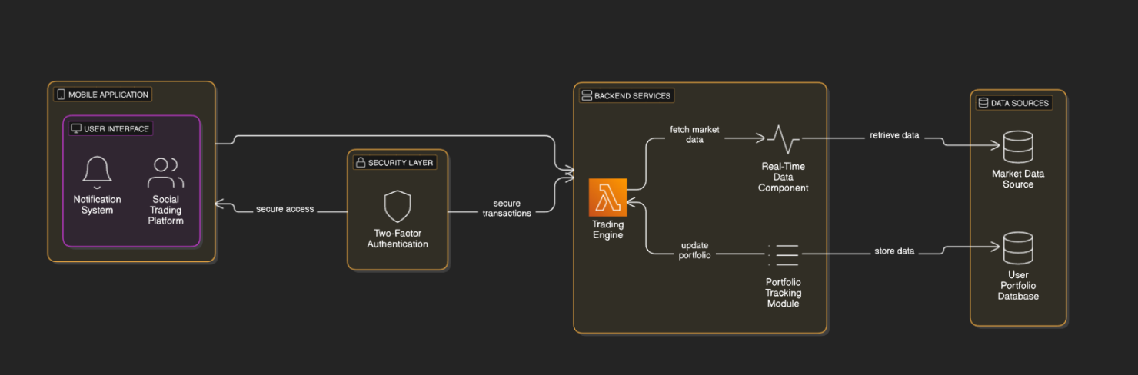

1. **Requirements for proposed work:**
2. **Software Requirements:** a. **Operating System**: Windows / macOS / Linux  
   b. **Frontend**: Android Studio with Kotlin  
   c. **Backend**: Firebase or REST APIs for real-time data  
   d. **Database**: Firebase Firestore or SQLite for local storage  
   e. **Styling**: XML for layout design, Kotlin for UI logic  
   f. **Navigation**: Android Navigation Component
3. Hardware Requirement:
   1. Processor: Minimum Intel i3 or equivalent
   2. RAM: 4GB or higher
   3. Storage: 10GB free space for development
4. **Bibliography/References**

* **Official Android Studio Documentation** – <https://developer.android.com/studio>
* **Kotlin Programming Language Documentation** – https://kotlinlang.org/docs/home.html
* **Binance API Documentation** (for cryptocurrency data and trading features) – <https://api.binance.com/>
* **Android Navigation Component Documentation** – <https://developer.android.com/guide/navigation>
* **Room Database Documentation** – <https://developer.android.com/training/data-storage/room>
* **Security Best Practices for Android** – <https://developer.android.com/training/articles/security-tips>